1TPIFI

Jason Gilson
PIF
2026

Contents
Lab sprints 2
L1 Raspberry Pi 2
Raspberry PI OS 2
Screen 5
SSH / I2C 7
Static IP address 8
Docker 9
Show website in Kiosk mode 11
L2 Database 13
Conceptual model 13
Logical/Physical Model 14
L3 Website 14
L4 Database Server 18
Apache installation 18
Mariadb installation 18
SQL 19
PHP installation 19
phpMyAdmin 20
FileZilla 20
L5 Data Transfer 23
Config.toml 23
Recieving.php 24
Proof 25
Problem/Solution 25
L6 Backup Server 26
Backup VM 26
Server VM 28
Workshop sprints 30
Userstory A1 30
Scraping / Punching 30
Drilling 31
Screwing together 32
Installing the display and raspberry pi 33
Userstory A2 35
Soldering 35
Put circuit board on the pvc plate. 37
Userstory A3 39
Cutting the cable in half 39
Removing the outer jacket 39
Removing the inner jacket and staggering 40
Removing the conductor shield. 40
Soldering 41
Heat shrink tube 42
Userstory A4 43
16Bit Converter and gas module 43
Userstory A5 45
BHI750 sensor 45
BME280 sensor 45
Problems 45
Userstory A6 46
Box Assembly 46
Button 48
Material List 49
Userstory A7 50
Experience 54
Equipment 54

Lab sprints

L1 Raspberry Pi

Raspberry PI OS
First you need to download the Raspberry Pi OS and flash it on a SD card.
- Install the Raspberry PI imager: https://www.raspberrypi.com/software
- Once opened you can specify your Raspverry Pi device (for us Raspberry Pi 4 Model B), the operating system you want and the device you want to save it on (in our case a SD card).
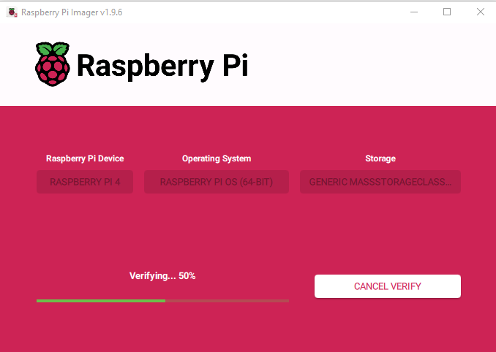

- Once you chose everything press write and you will be asked if you want to flash the SD card or if you want to Edit the settings, press edit settings.

- On the general tab you can set a hostname, create your username and password, connect to a WLAN and select your timezone and keyboard layout.
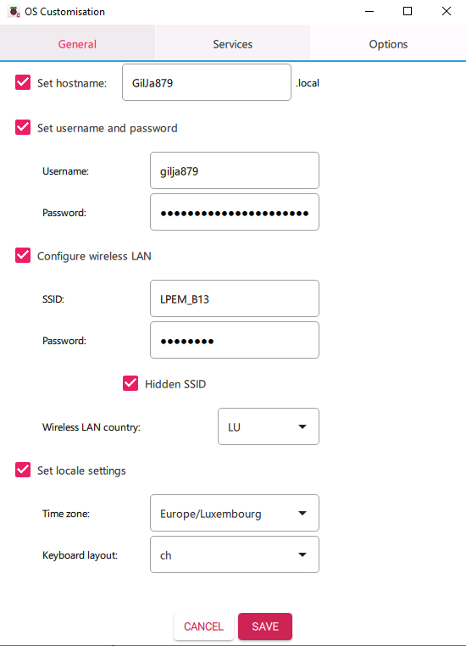

- On the Services tab, enable SSH and for now you can use a password since we don’t have a public-key yet.

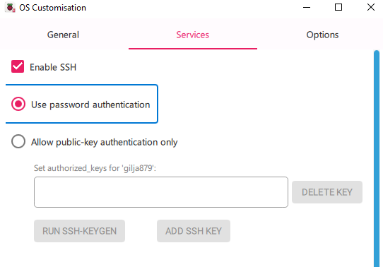

- Once you edited the settings to your needs you can go back and start writing the OS on the SD card.
- Only remove the SD card after getting a alert that tells you that the OS is finished flashing on the SD.

Screen
- Once you connected the screen to the Raspberry Pi you can start it (this can take a few minutes, then the screen will turn on)
- Now to rotate the screen horizontally you have to go to the top left and click the Raspberry Pi logo, then to preferences and then to control centre.

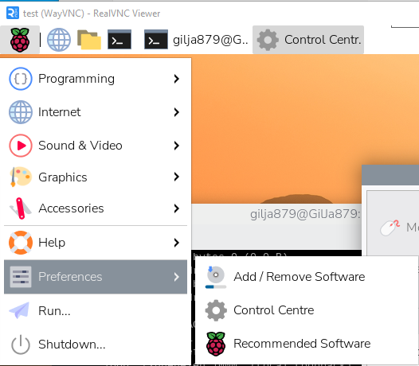

- On the left scroll down to the Screens tab, then right-click the monitor, choose Orientation and select Right.
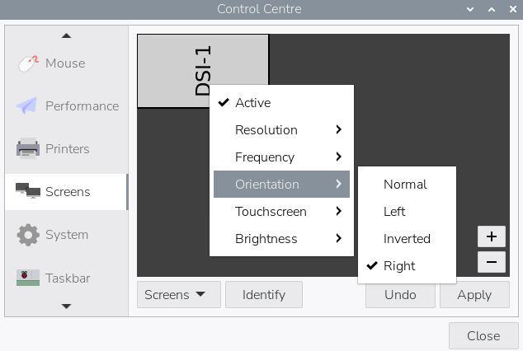

- Press Apply and the screen will be horizontal (if you already connected your VNC viewer you will have to restart the connection to see the rotation)

SSH / I2C
- To connect to your Raspberry Pi via VNC viewer you have to first enable SSH, this is also done in the control centre.
- Navigate to the Interfaces tab and enable SSH, I2C and VNC.
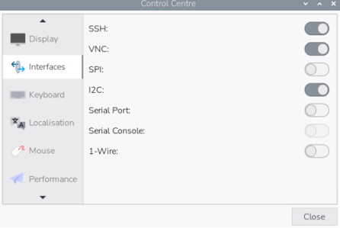

- Now start your VNC viewer and create a new connection, as VNC Server you can either type your hostname or your IP address and the Name can be whatever you want it’s just a name that will show in your connections.
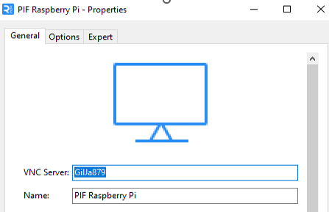

Static IP address
- To set a static IP address we need to install dhcp, open your terminal and type the following command to install dhcp.

- Once dhcp is installed you can open the dhcpcd.conf file by the following command.

- In the file you will go to the bottom and add the lines under slaac private.
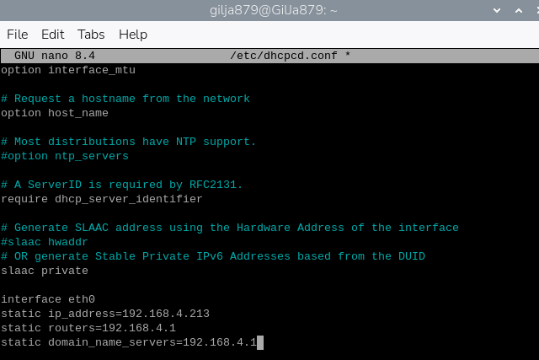

the first line tells dhcp which interface to use, the second line is the static ip address you want to use, the third line is the routers ip address and in our case the fourth line will also be the router ip address.
- Once you edited the dhcpcd.conf file you have to enable dhcp with the following command:

- Now start your dhcp with the following command:

Docker
- Install docker with the following commands (write them one after the other in your terminal) :

- Once that is done create a new directory where you will store the files given to you.
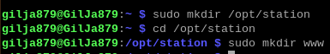

- Download the files given to you.

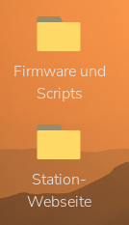

- Navigate to the desktop and move the downloaded files into the directorys you just create as shown below:
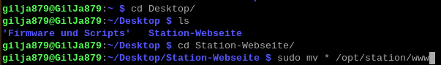

- Now navigate to /opt/station and open the config.toml file to check if everything went correctly with the following command:

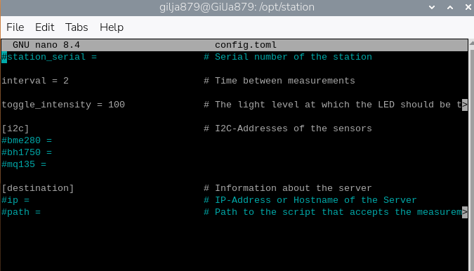
The file should look like this:

- Now to start docker write the following command in your terminal:

Show website in Kiosk mode
- Install wtype with the following command:

- Enter the following command to edit the autostart file:
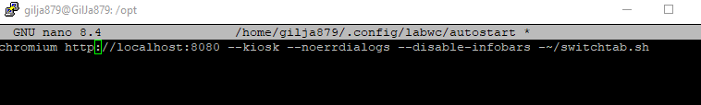
- In the file copy the line below:

This will start kiosk mode when the Raspberry Pi starts and show the correct website.
- Open the switchtab.sh file:
- In here copy the code that was provided to you:
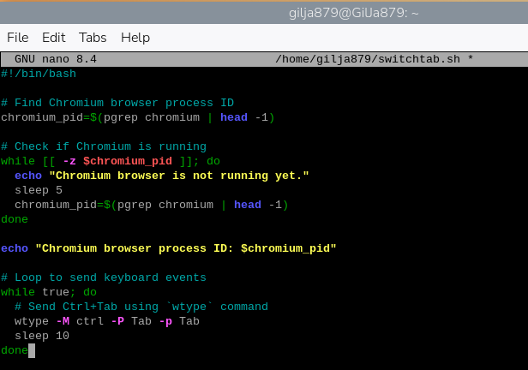

- Now give yourself execute rights for the switchtab.sh file:
- Reboot the Raspberry Pi:

- After the reboot, wait a few seconds and your screen should then show this website of the measurments:
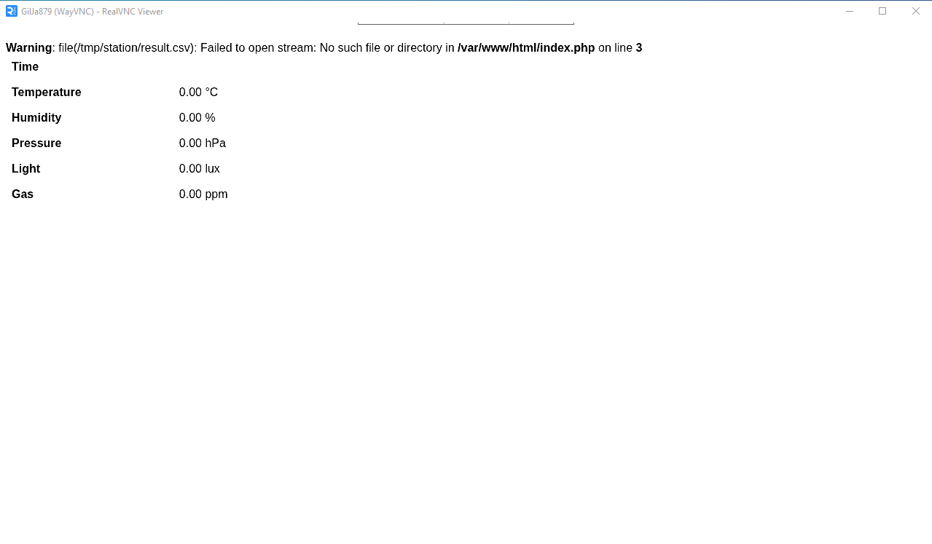

L2 Database

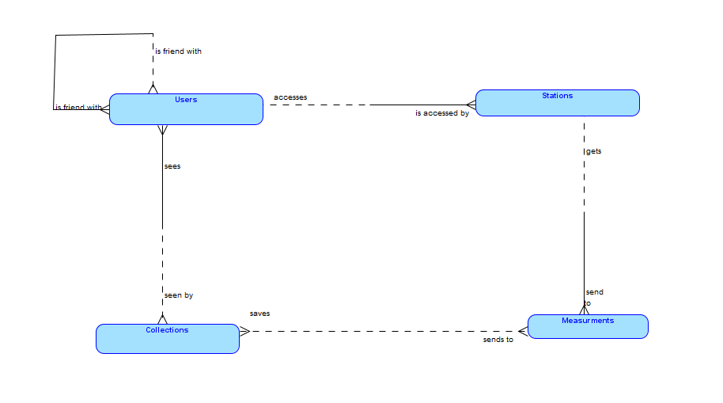
Conceptual model

Logical/Physical Model
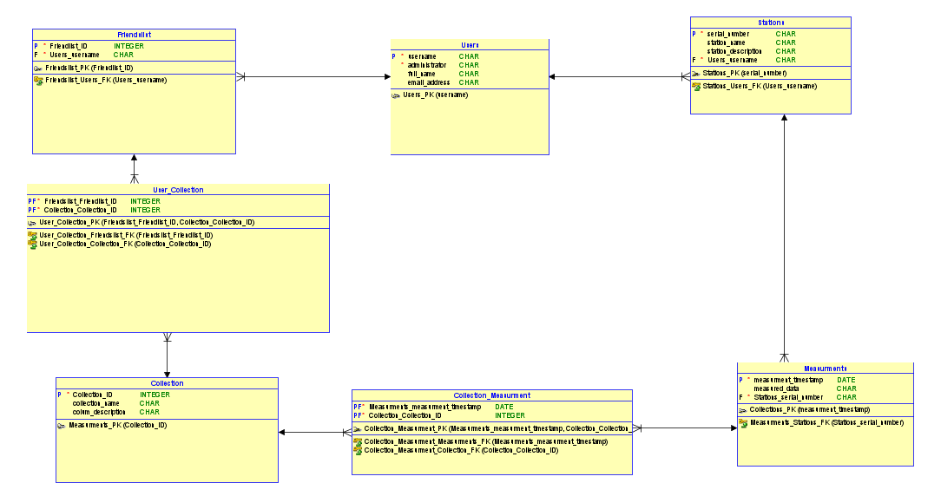

L3 Website
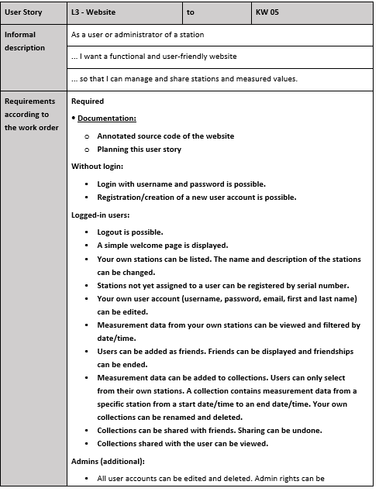

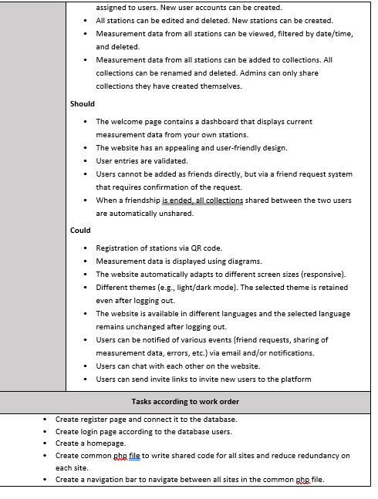

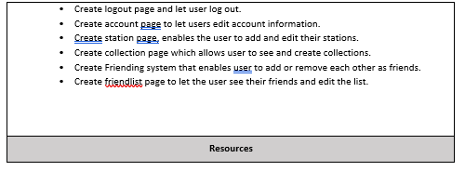

L4 Database Server

Apache installation
Apache is easily installed by just using this command:

To check if Apache is running us the following command:
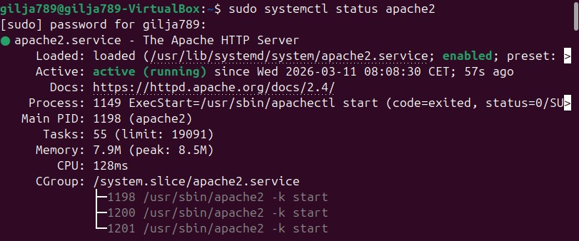

Mariadb installation
Type the following command to install maria db

Then start mariadb with sudo systemctl start mariadb.
To check if it workes use sudo systemctl status mariadb.
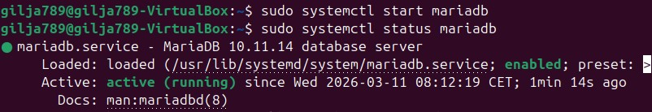

SQL
To start a sql line you write sudo mysql, since your mariadb is running it will activate in your sql line.
The commands you must use are marked by orange boxes.
- First you create a database (in my case I create a test database, but when you already want to add your website create a database with the same name as the one used in your website.
- Then you create a sql user and give it a password.
- Afterwards you give the user rights to your new database.
- Finally you flush the privileges which saves the rights for your user.
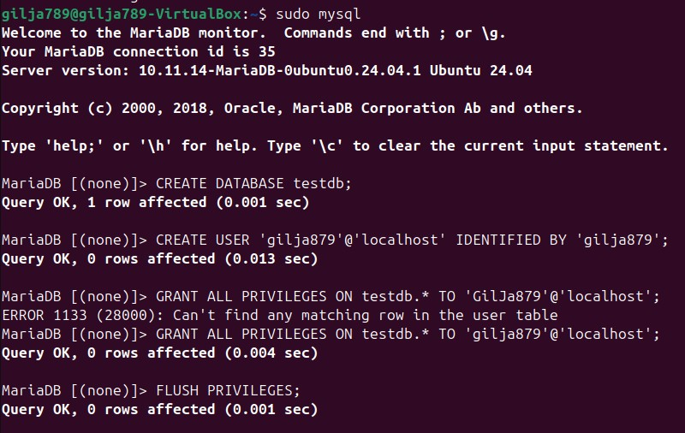

PHP installation
Copy the following command to get all php extensions you need for your apache.

Then restart your apache to make sure it uses the php.

phpMyAdmin
First, we install a tool to unzip zip files.

Then copy this command to get the zip file for phpMyAdmin.

Now we use the unzip tool and unzip the phpMyAdmin zip file.

Then move the unzipped files to /var/www/html so that you can access it via “your ip address/phpMyAdmin”.

Finally give your sql user rights for the directory so you can login with your sql user in phpMyAdmin.

FileZilla
First we need to install ssh so that the we can access the vm from the host machine.
!!! Make sure to have bridged adapter and not NAT in your network settings!!!

Once installed we will now start ssh and enable it so that it will always automatically start.

Use following commands to set up ssh.
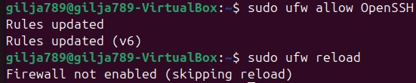

Now on your host machine open Filezilla and enter the ip, username, password and the port (22).

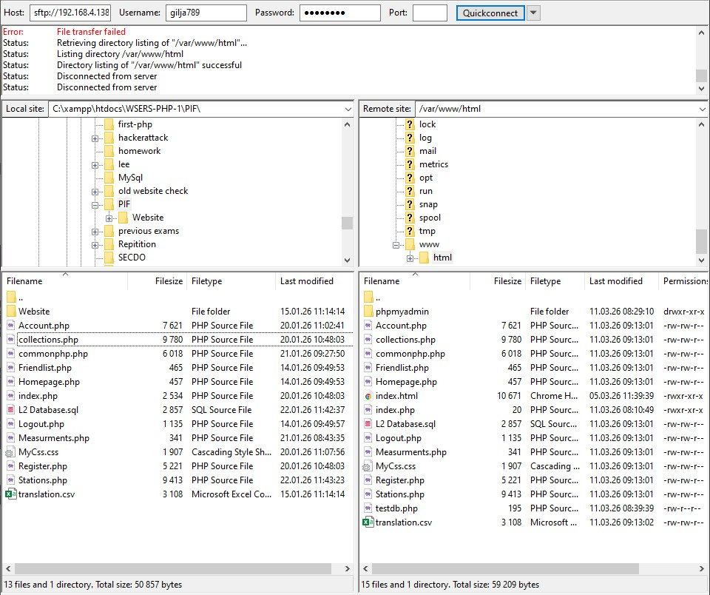
Once you moved your website into the /var/www/html directory you should be able to access it from your vm.
If you have a database make sure to change the mysqli_connection variables to your new username and password (your sql user).

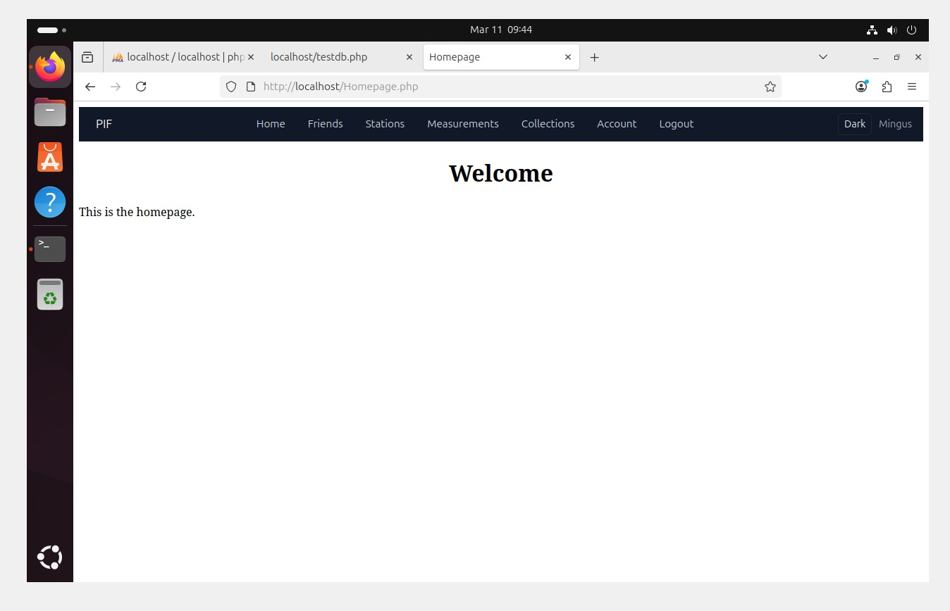

L5 Data Transfer

Config.toml
I made some changes in my conifg.toml file.
- station_serial = 1 | Changed the station serial number to the number of my station.
- Ip = “192.168.4.47” | Changed the ip address to the ip address of my server (VM).
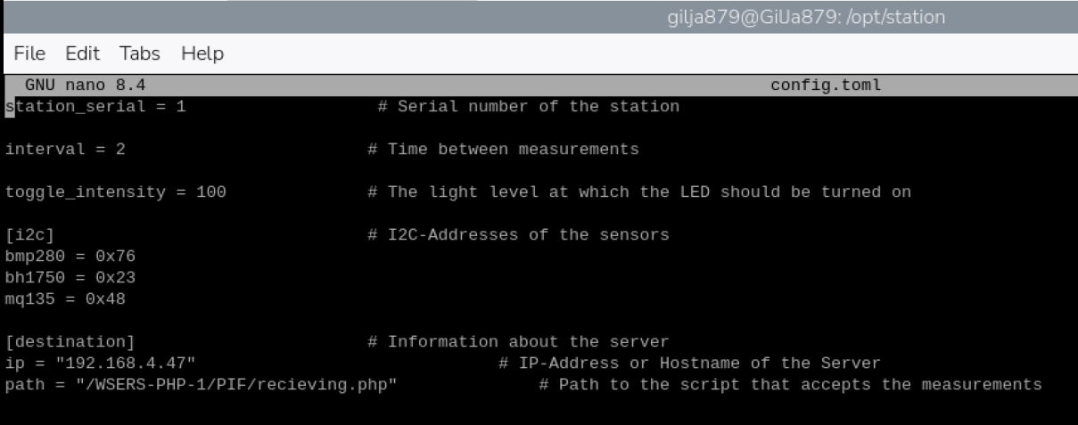
- Path = “/WSERS-PHP-1/PIF/recieving.php” | Changed the path to the path of the newly created php file that recieves the data from the station.

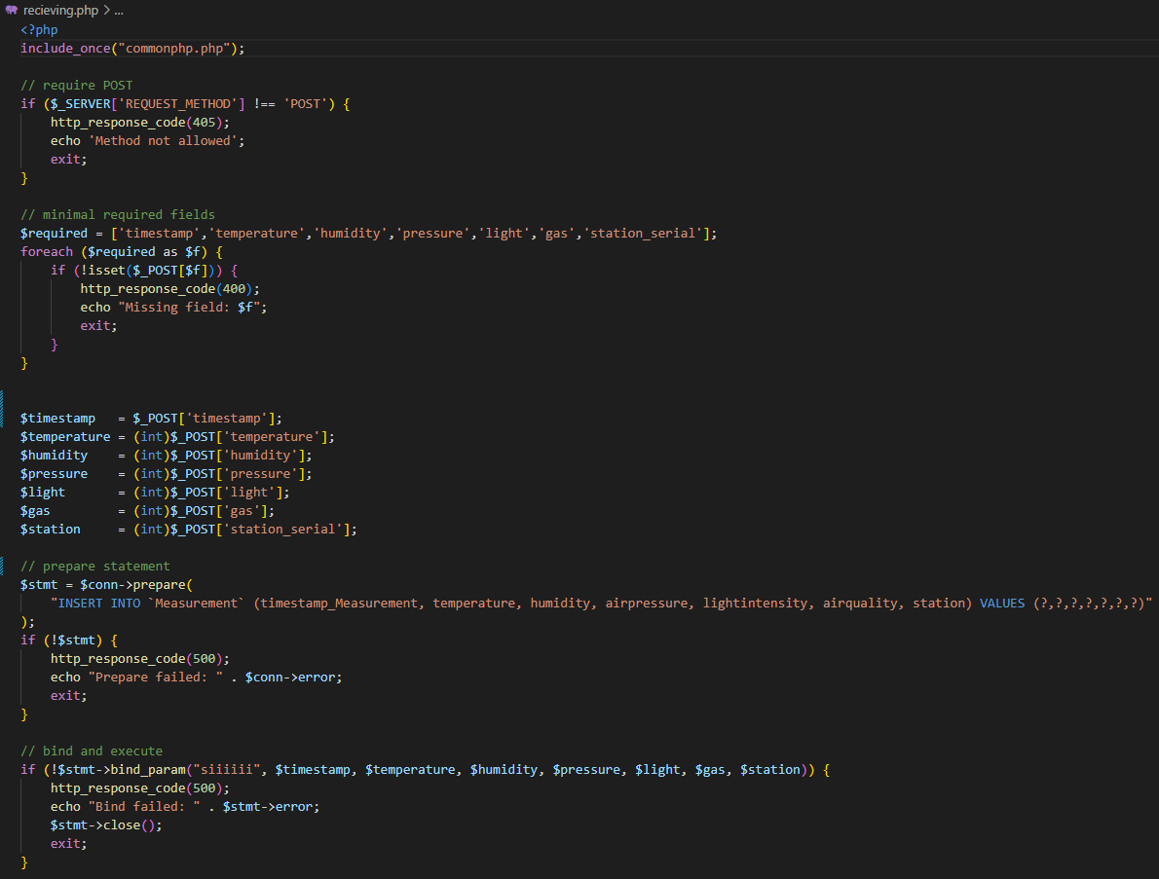
Recieving.php

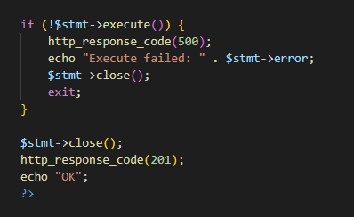

This script will get the measurments using the POST method and then write the data into the database.

Proof
To show that the measurments are being send to the database, I simply ran the measurment table and checked if measurments are being added.
I attached a video of the more data being added as proof.

Problem/Solution
Since my website cannot be accesed without being logged in, the data could not get sent to the recieving.php, I had to change my commonphp code to allow the acces to the recieving.php so that the measurments can be put in the database.
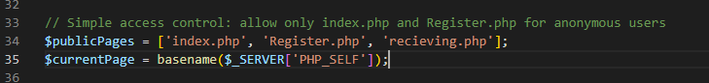

I simply added the recieving.php to the sites that are accessible without being logged in.

L6 Backup Server

Backup VM
First install mysql on the new vm.
Then create a directory where you will later save the backups.
Create a new user and give him rights for the backup directory.
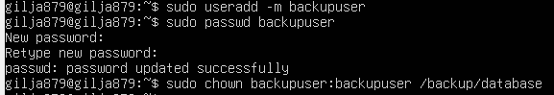

Create a sh file in /usr/local/bin. This script will create the backup.
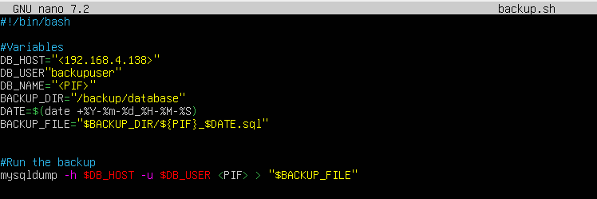

sudo

Make the sh file executable.

Create the crontab to schedule the backups.

Change this line. This will run the sh file every day of every month, all year at 8 AM.

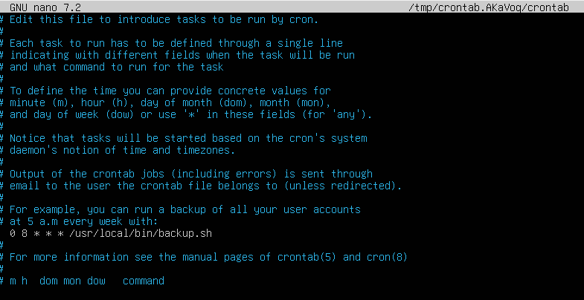

Now set up FTP access, first install vsftpd.

Create a ftp user.
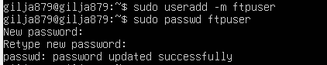

Give the ftp user rights.

Enter the vsftpd.conf
And uncommand write_enable=YES and local_enable=YES

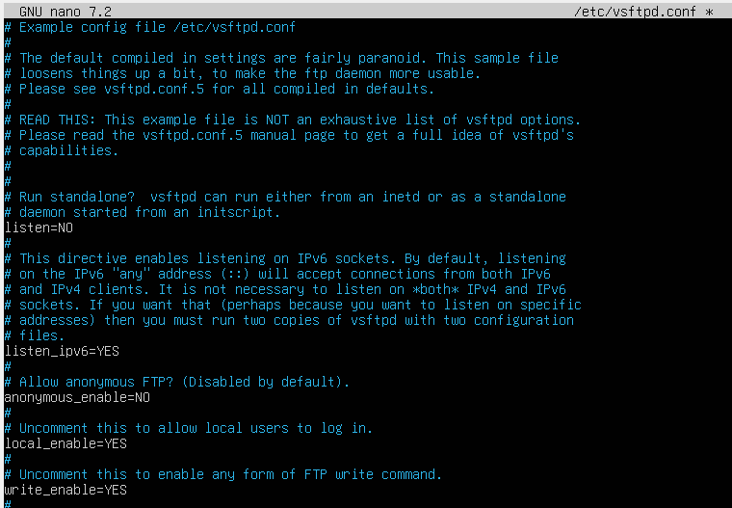

Server VM
Enter mysql as root user.

Create the user from the backup server in your database.

And give him permission for the database.

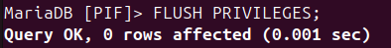

Now allow MYSQL to accept external connections, to be able to connect to the backup vm.

Change the bind address to 0.0.0.0 to allow all ip addresses.

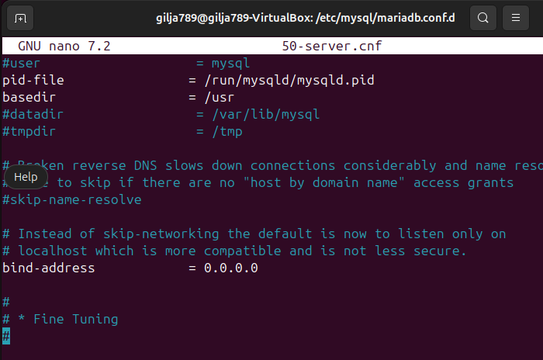

Finally back on the backup vm, restart vsftpd.

Run the sh file to test if the backup is being saved.
Go to the backup location to check.
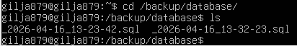

Workshop sprints

Userstory A1

Scraping / Punching
First, I scraped lines according to the measurements of the holes and then punched where the hole is supposed to be, that helps as a guiding hole for the drill.

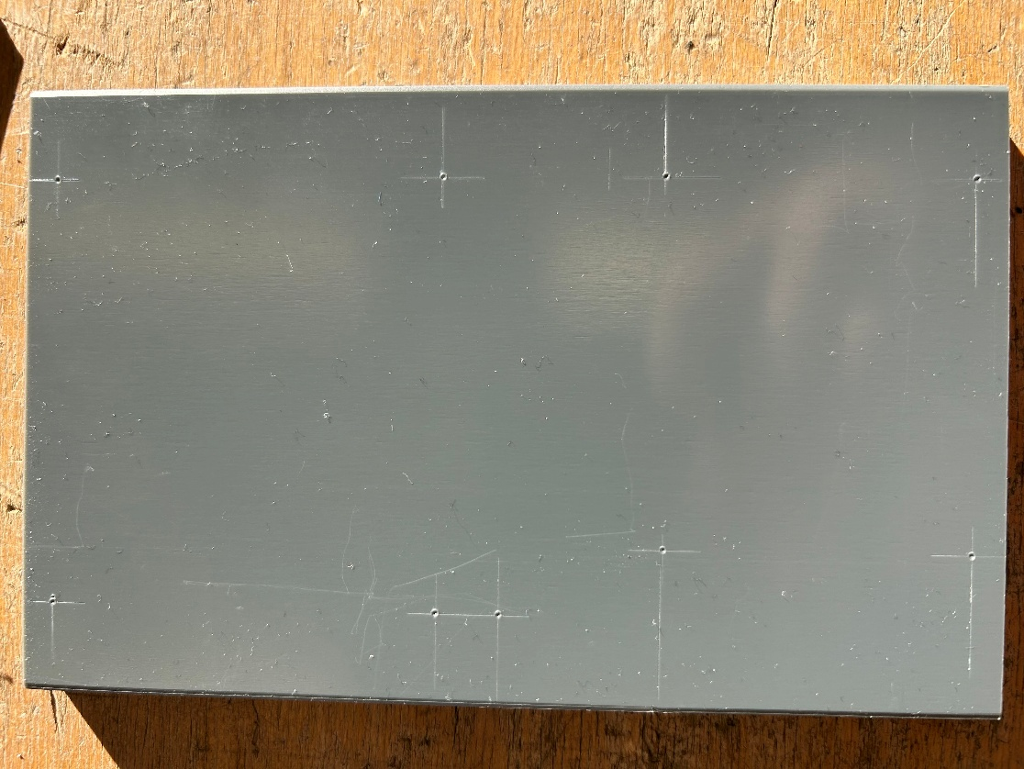


Drilling

I then drilled out the holes, the holes on the side had to be drilled with a special drill so that the screws can be screwed in.
And for the square in the middle of the plate I made 4 big holes on the edges and then sawed out the rest of the square.
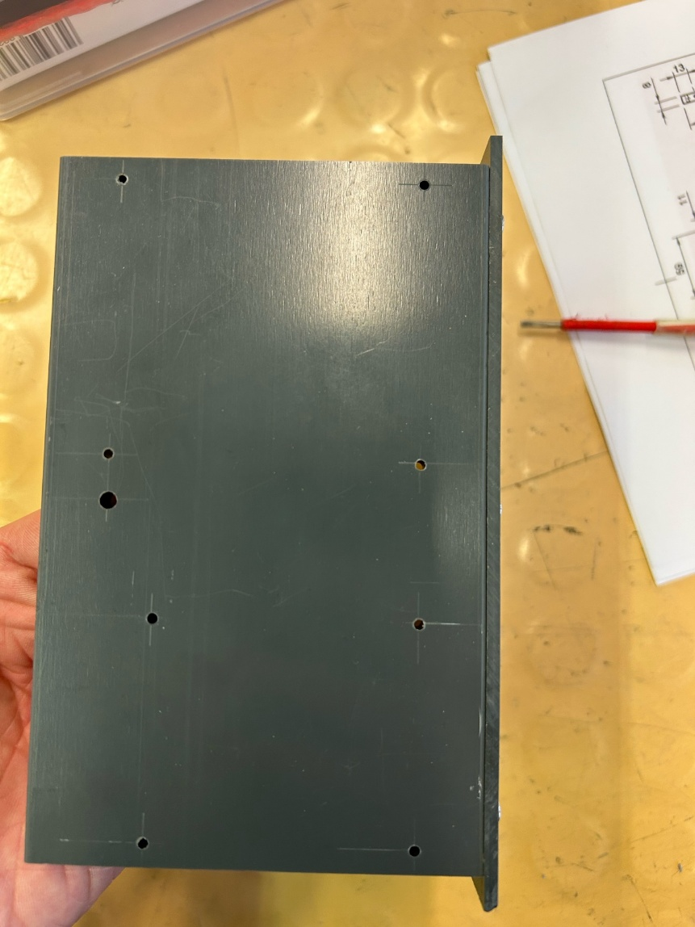
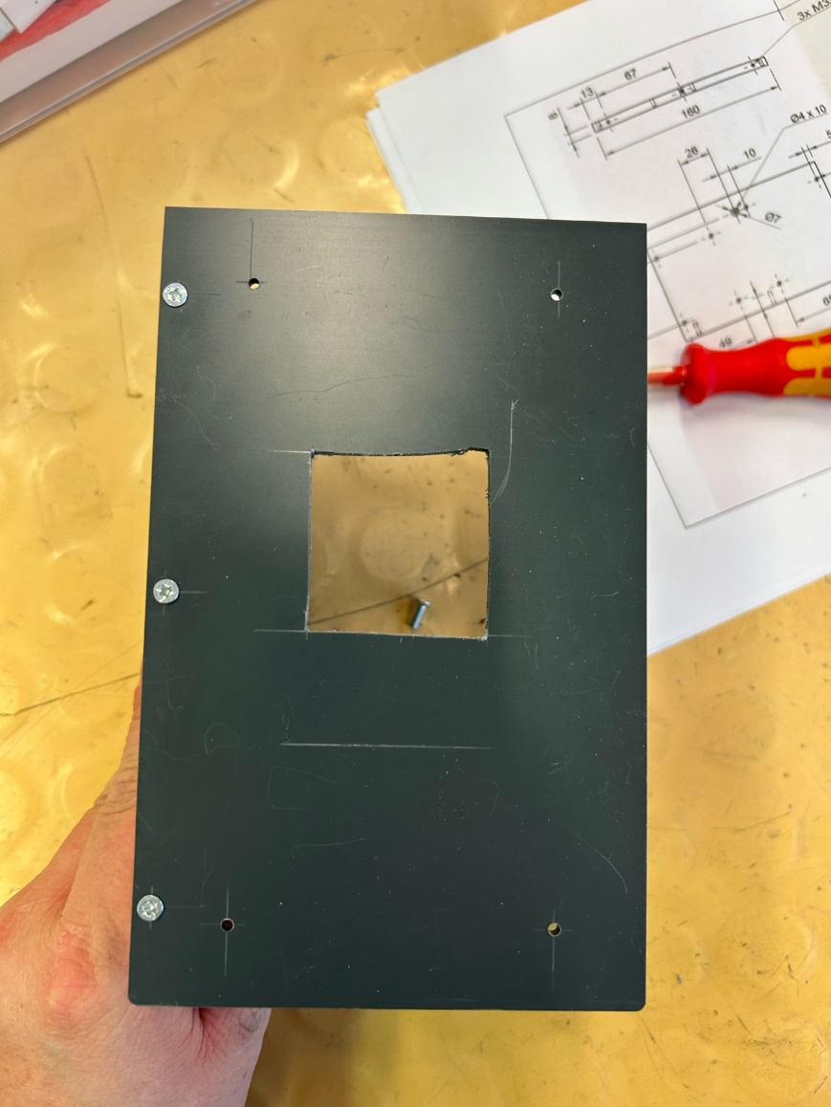

Screwing together
I then screwed the two plates together.
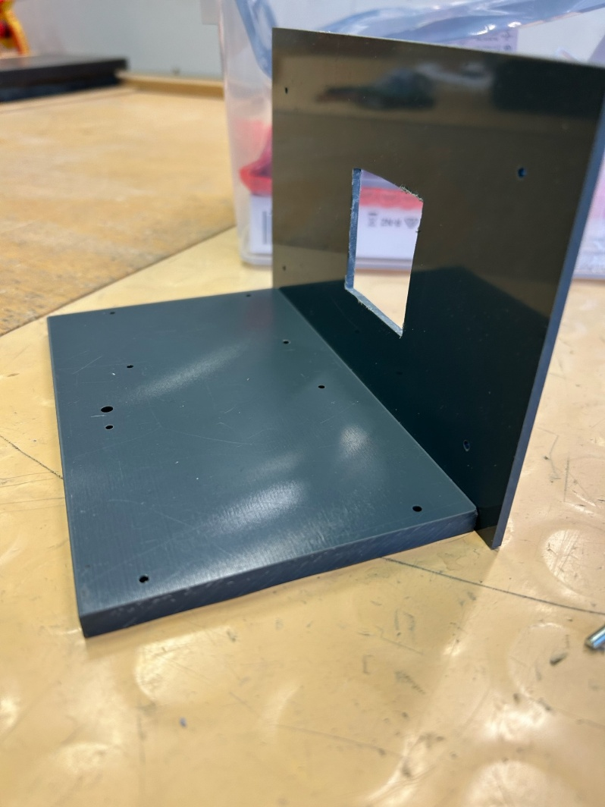
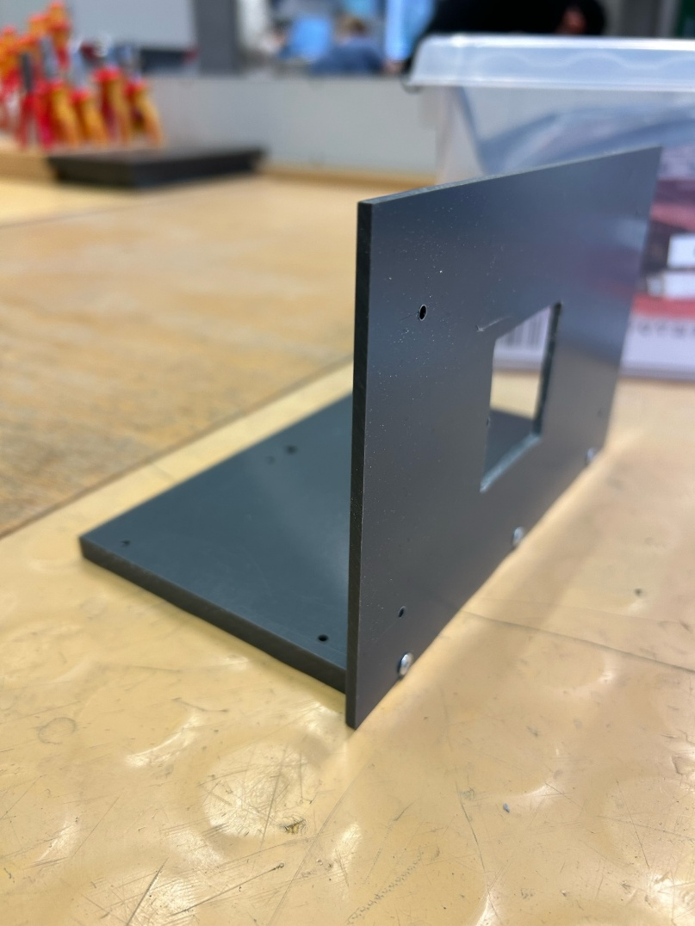

Installing the display and raspberry pi
Now I screwed in the display on the front plate in the holes I drilled earlier, and the square is there to put the cables trough to connect the display to the raspberry pi.

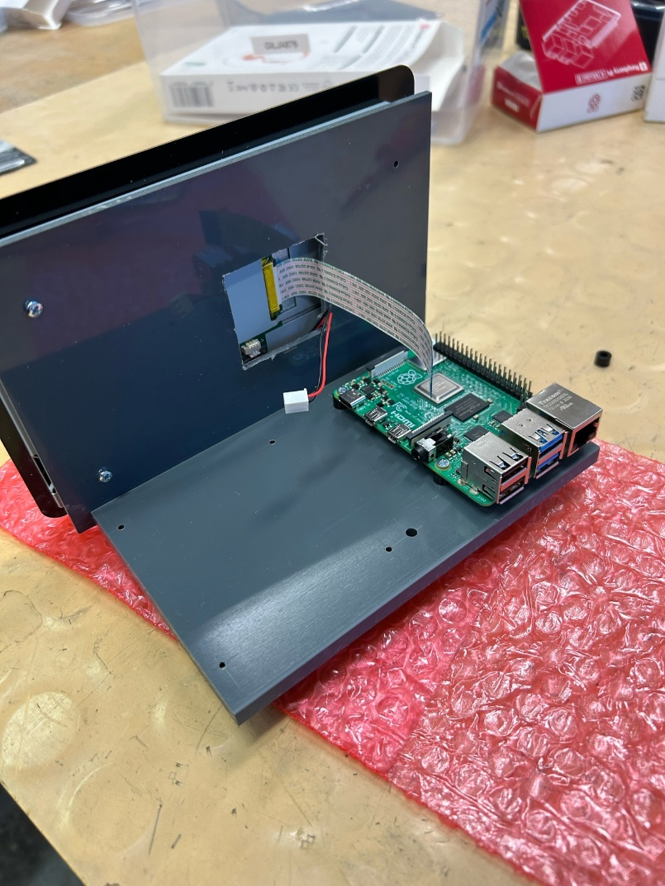
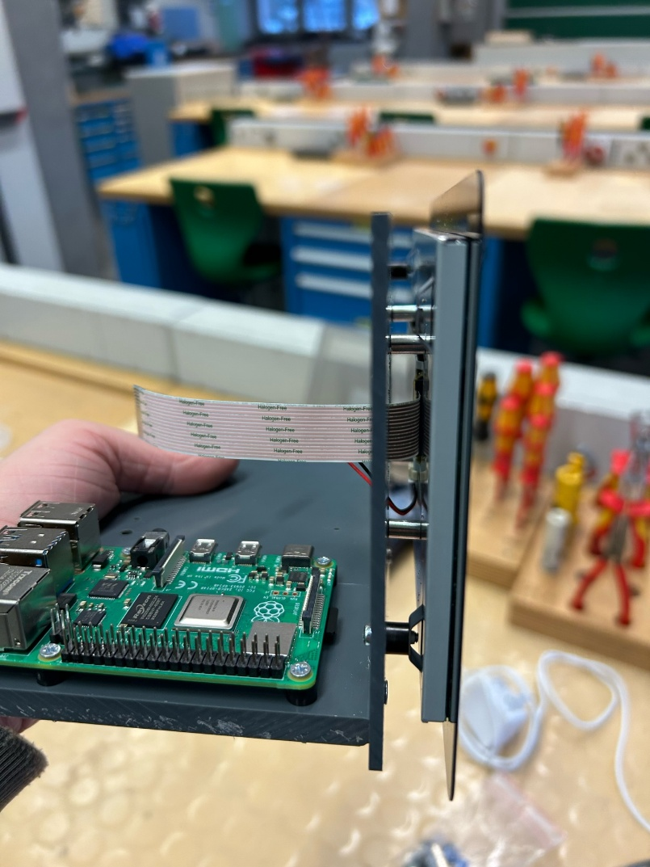

To screw in the raspberry pi, we used spacers so that the bottom of the raspberry pi can’t be damaged.

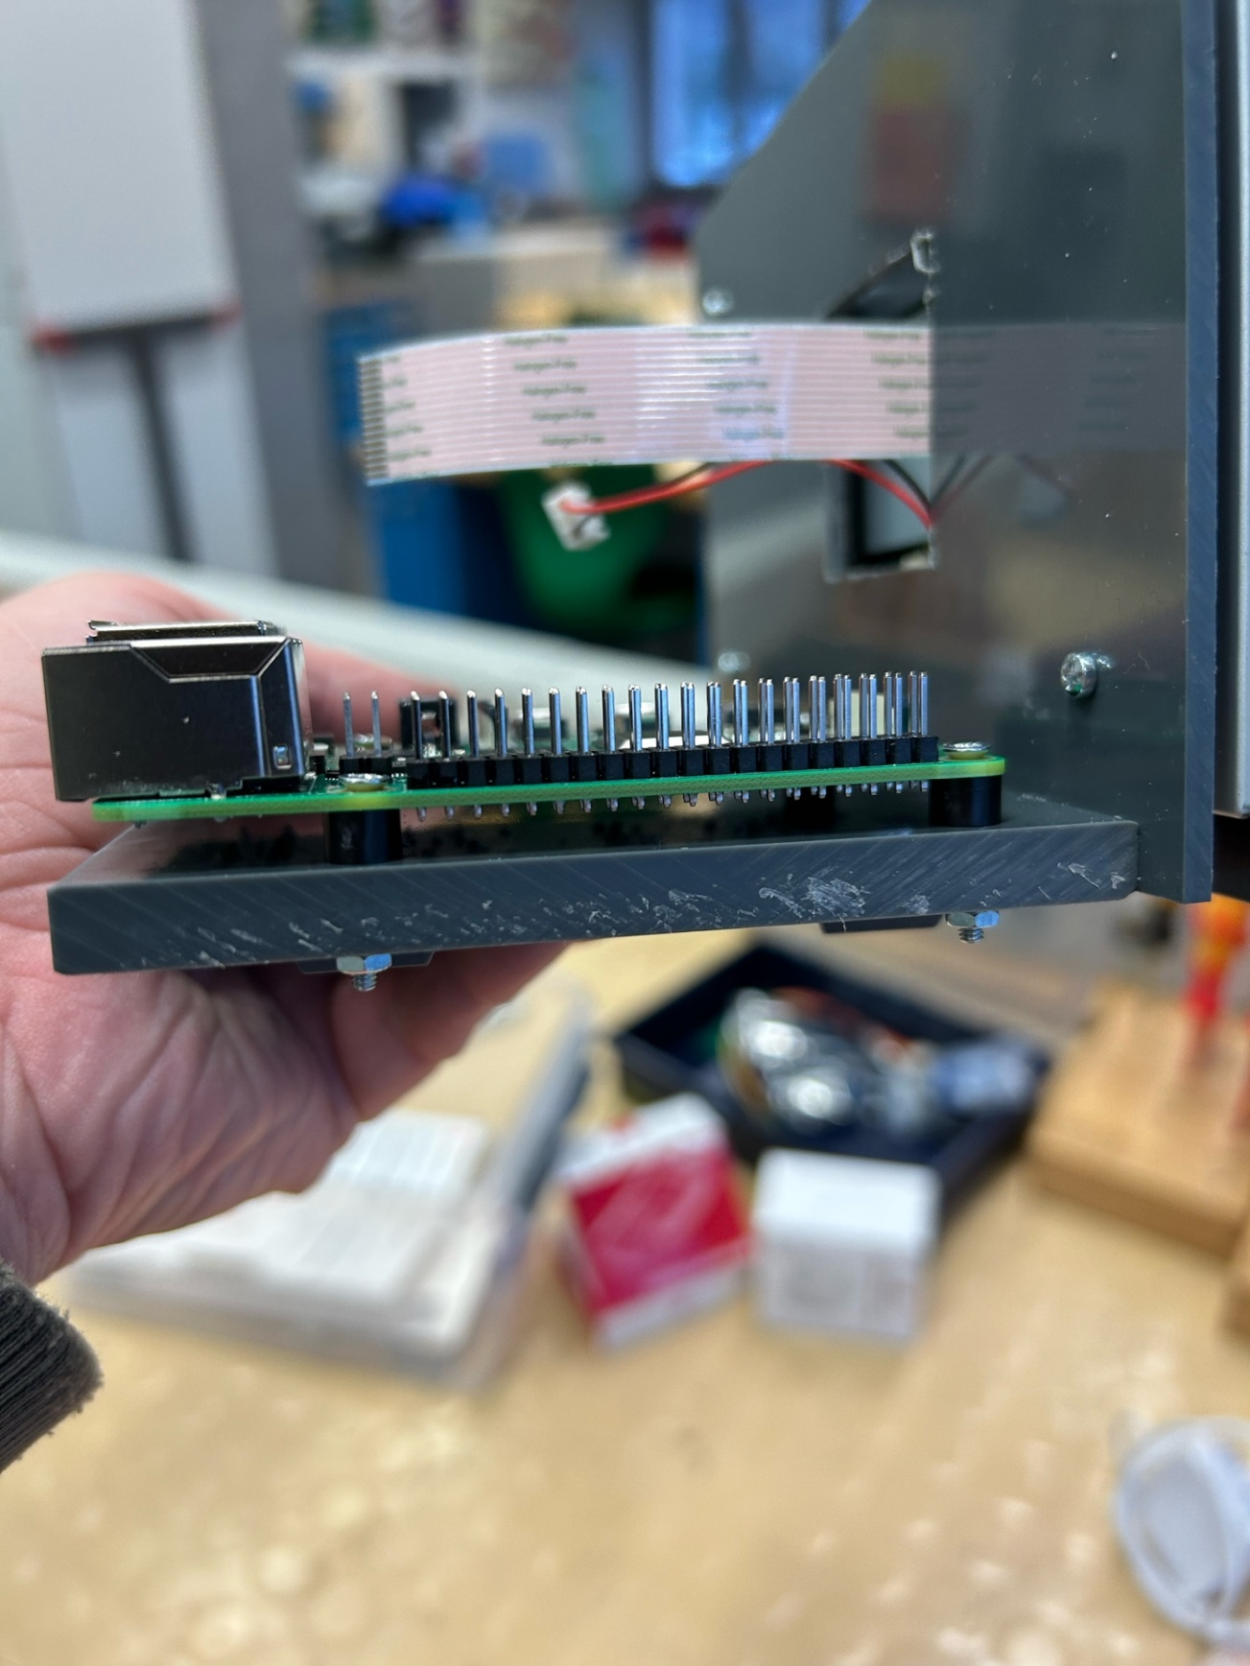

Userstory A2

Soldering
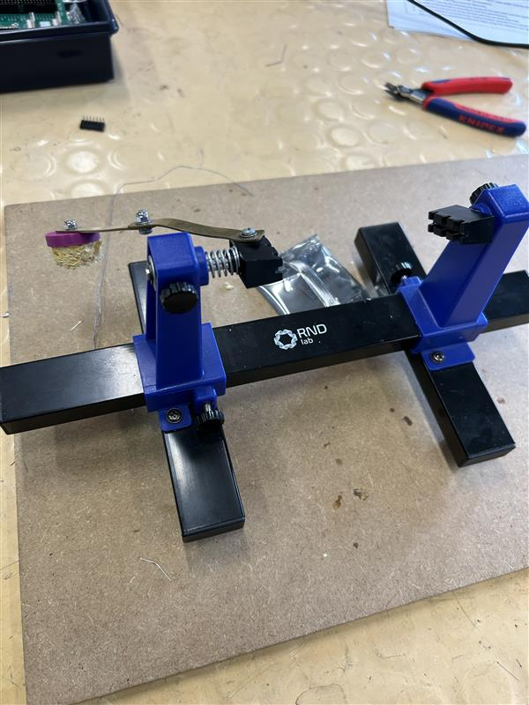
First, I put my circuit board in this holder so it’s easier to solder everything on the board, it makes it more accessible.

I Then soldered every component onto the circuit board; I started with eh smallest pieces to make it easier to reach.
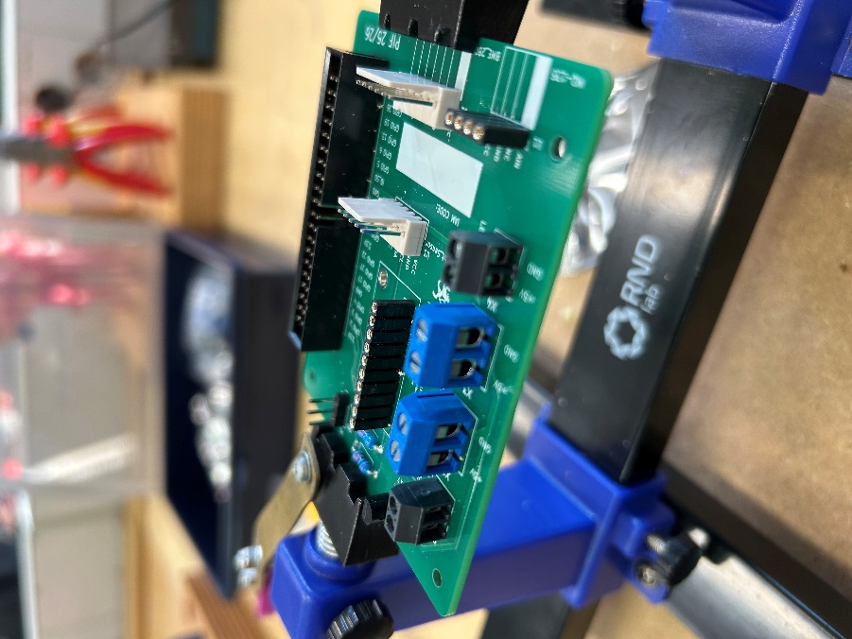

On the underside I cut off the parts that were too long with a flush wire cutter, so it will fit and nothing can get caught on it.
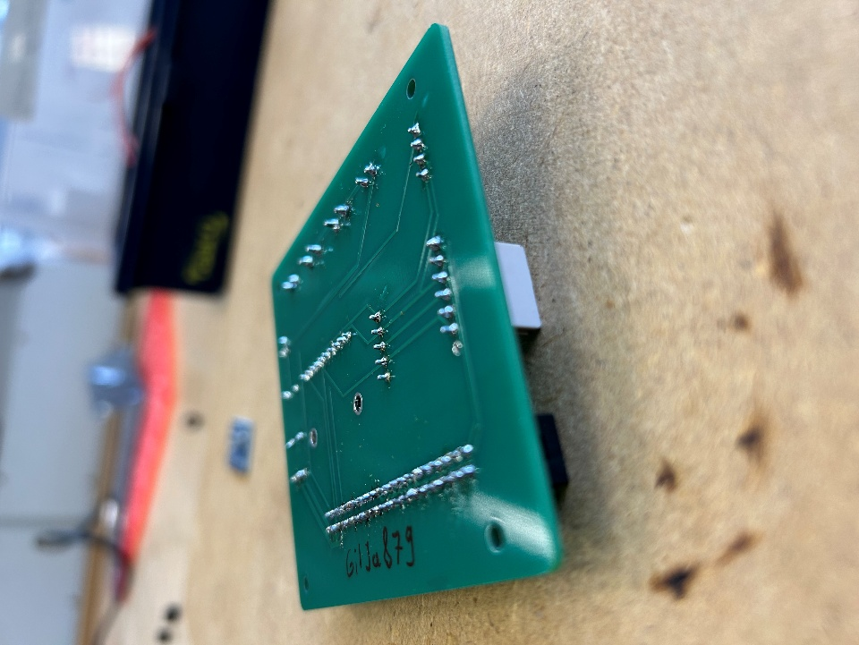
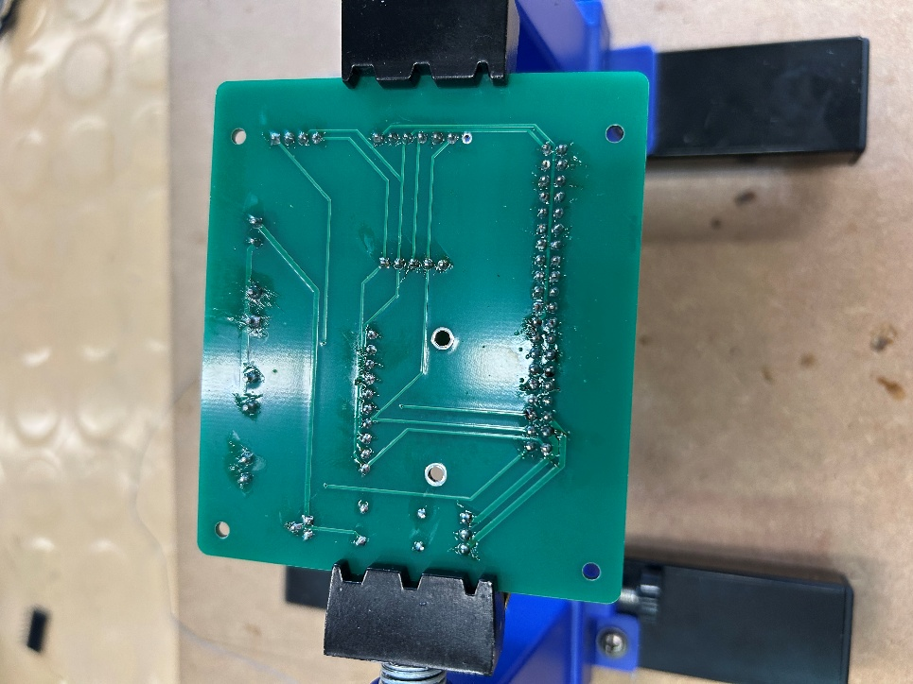

The finished circuit board:

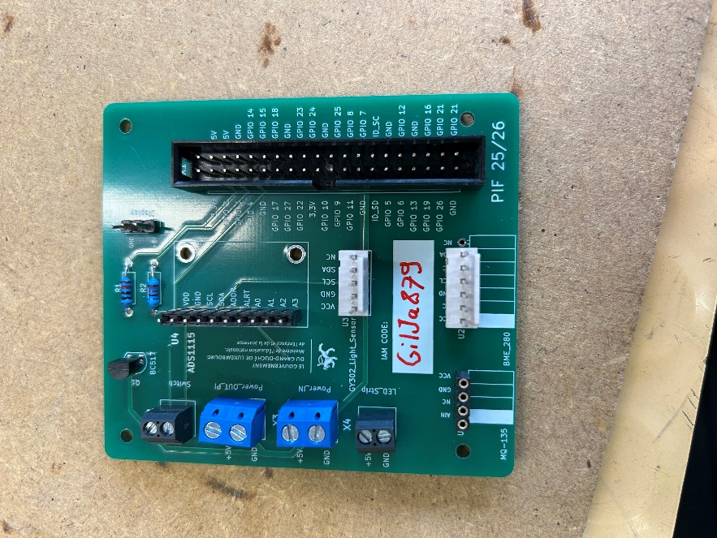

Soldering station:

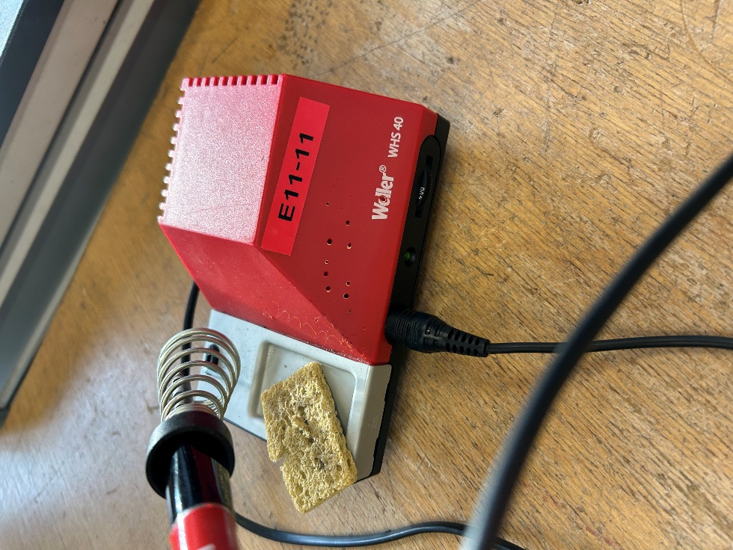

Put circuit board on the pvc plate.
There are 4 screws that will hold the circuit board down on each edge.

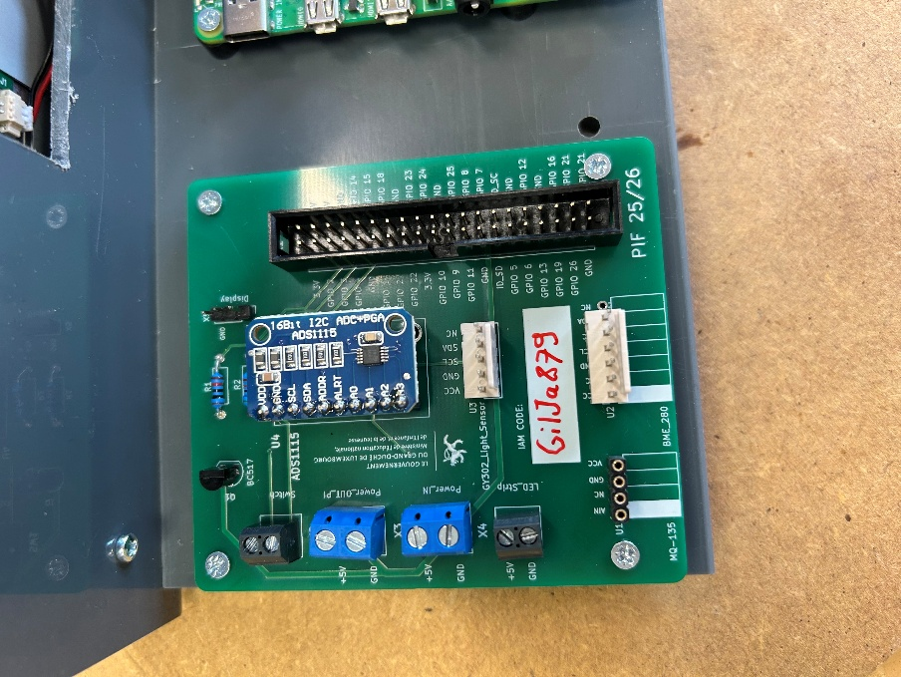

Between the circuit board and the pvc plate there will be 4 spacers, where the screw goes trough so that the circuit board can’t get damaged.

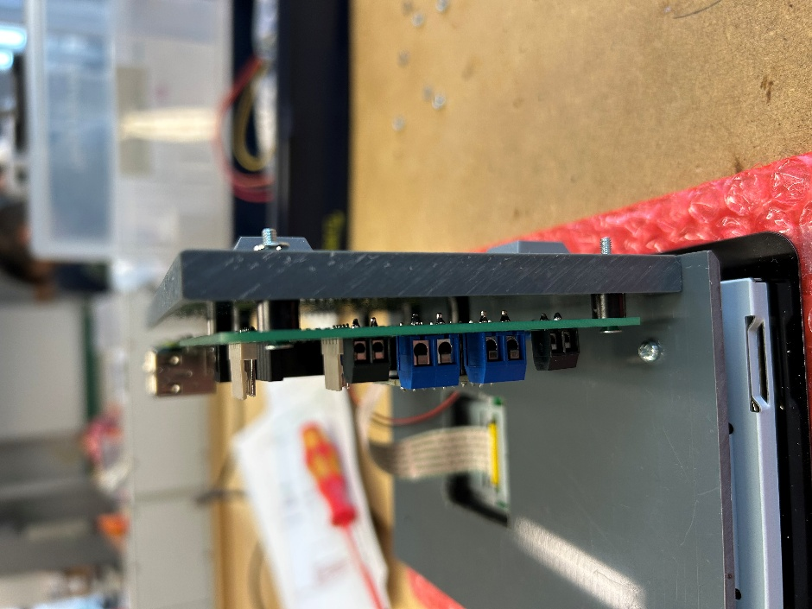

On the back to hold the screw in place, I put a washer on each screw and then screwed in a nut on each screw.
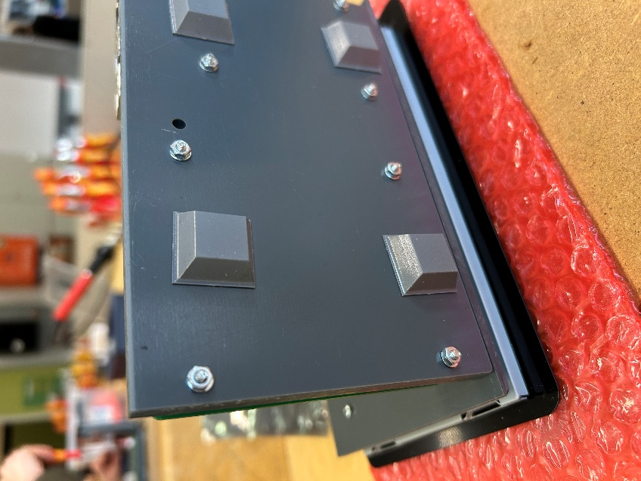

Userstory A3

Cutting the cable in half

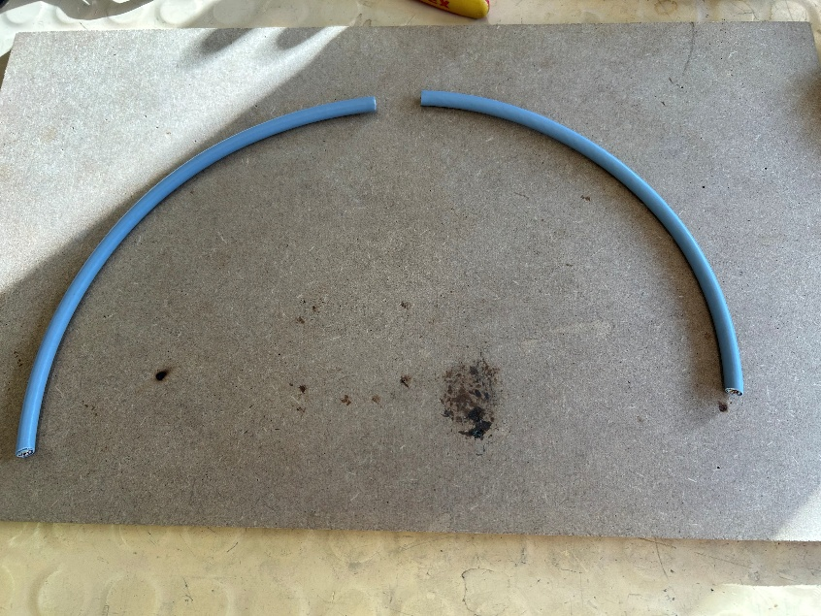

Removing the outer jacket
I removed the first jacket with a wire stripper and pulled back the shield to not damage it.

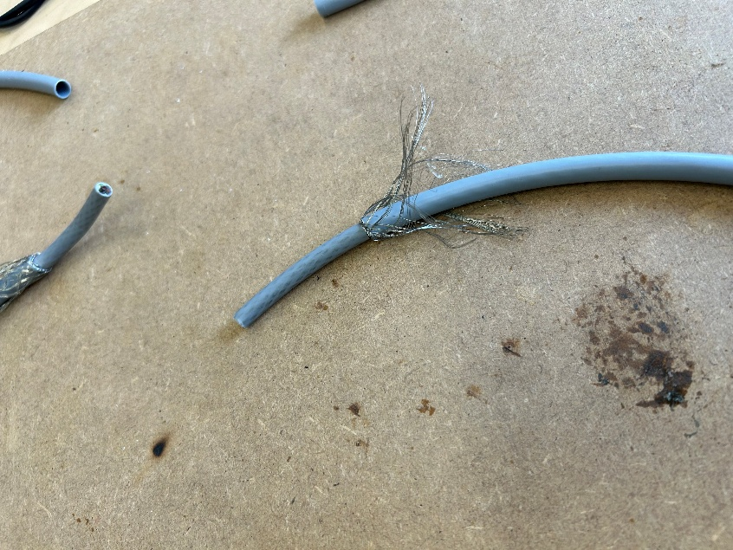

Removing the inner jacket and staggering
Then I removed the inner jacket to reveal the conductors. Afterwards I will put each conductor next to each other and cut in the middle so that all the conductors will be the same length.
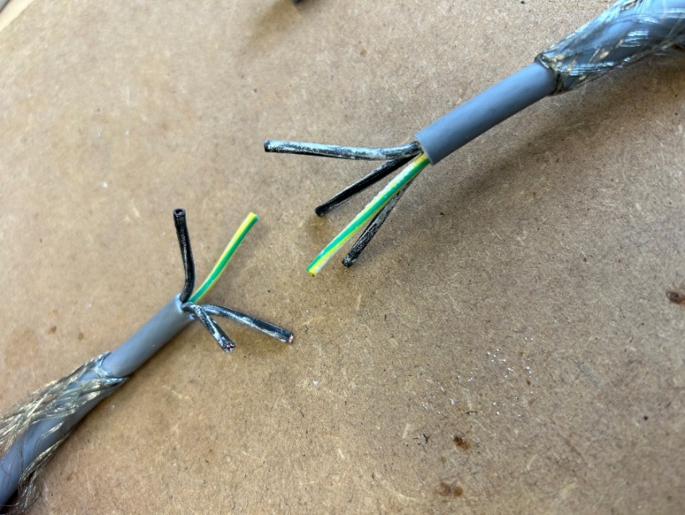

Removing the conductor shield.
After I removed the shield from the conductors with a wire stripper to reveal the copper, which allows me to connect the cables together.

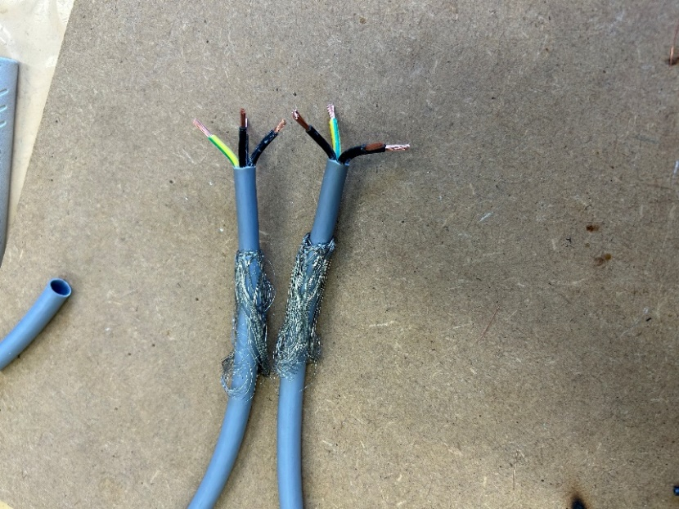

Soldering
Then I soak the copper wires in solder, then I will just put both ends together and heat them up until the solder will connect both ends together.

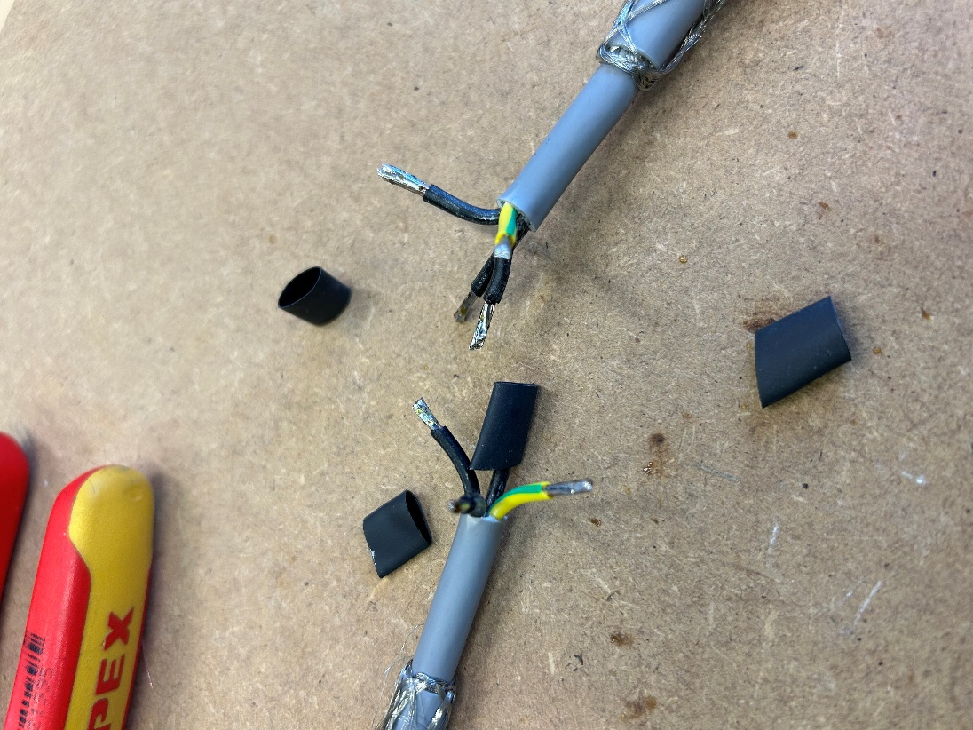

Heat shrink tube
After the conductors are connected I put the heat shrink tube over the soldered spot and heat it up with a heat gun to make it shrink in position, protecting the soldered spot.

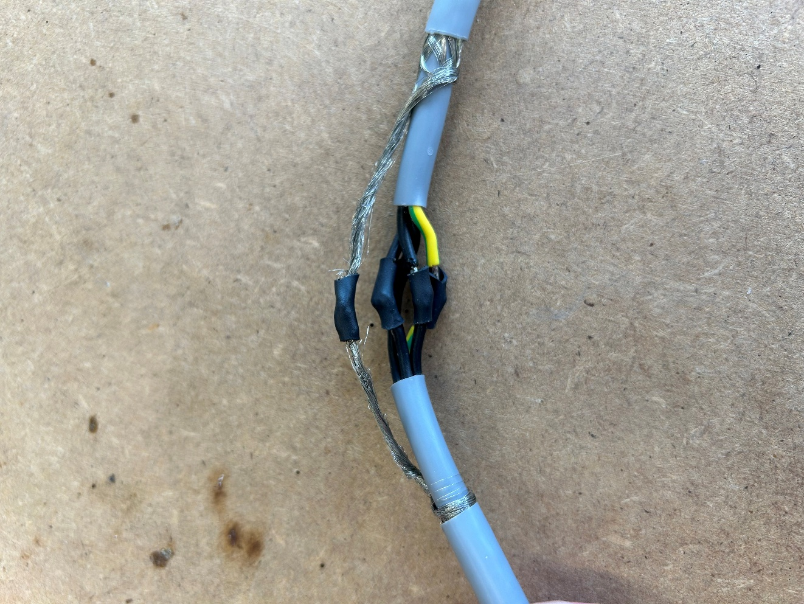

Userstory A4

16Bit Converter and gas module

First, I soldered the sensor onto the pins and then put them on the connectors on the circuit board.
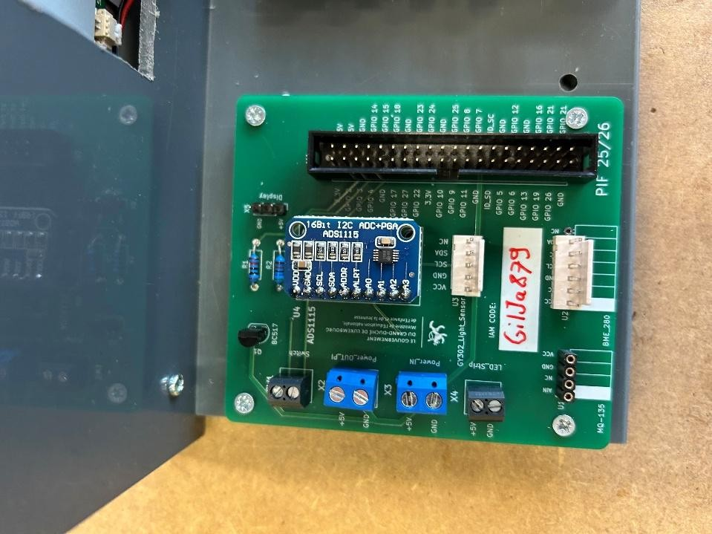

To prove it worked, I checked with a command to see if the sensor can see the other sensors:
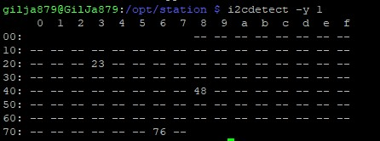

Afterwards I put the gas module on the connectors on the raspberry pi.
To see if it works, I used a command to read the measurements of the gas module a few times to see if it changes (Result in the video attached).

Userstory A5

BHI750 sensor
First, I soldered the sensor to the wires we were provided with and simply plugged the connector of the wires onto my circuit board.
To test if the sensor gets any data, I ran the python test script to see if I get different results depending on how bright it is since this is a brightness sensor. (video attached).

BME280 sensor
Same as for the bhi750 sensor I first soldered the sensor to the provided cables and then simply plugged it onto my circuit board.
To test I also ran the python test file of this sensor to see if I get data. This sensor reads air pressure, temperature and humidity. (video attached).

Problems
There was a problem with the script we were provided with, for the BME280 sensor so it took a long time to figure out how to get data. I found a problem was the library we used for the sensor and after some research I found a working library, but the sensor can now only show temperature and air pressure, not the humidity. I still have to fix this issue.

Userstory A6

Box Assembly
First, I prepared and drilled all the holes in the wooden plates.

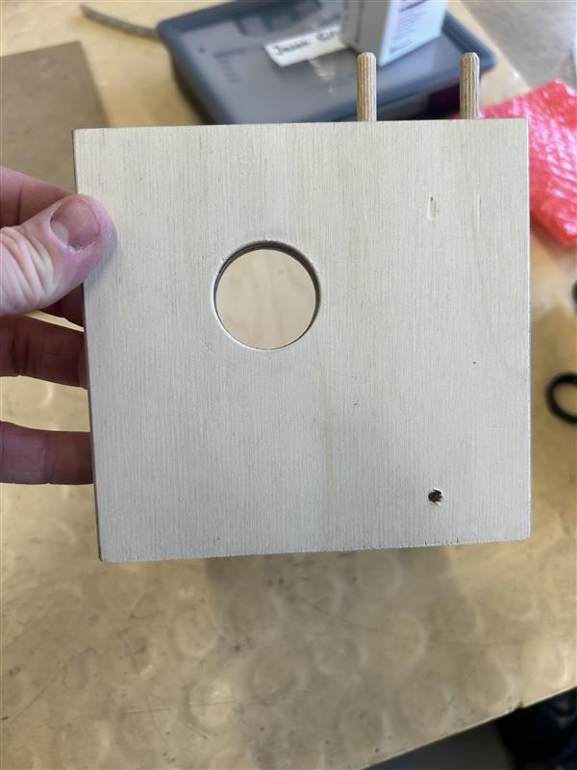
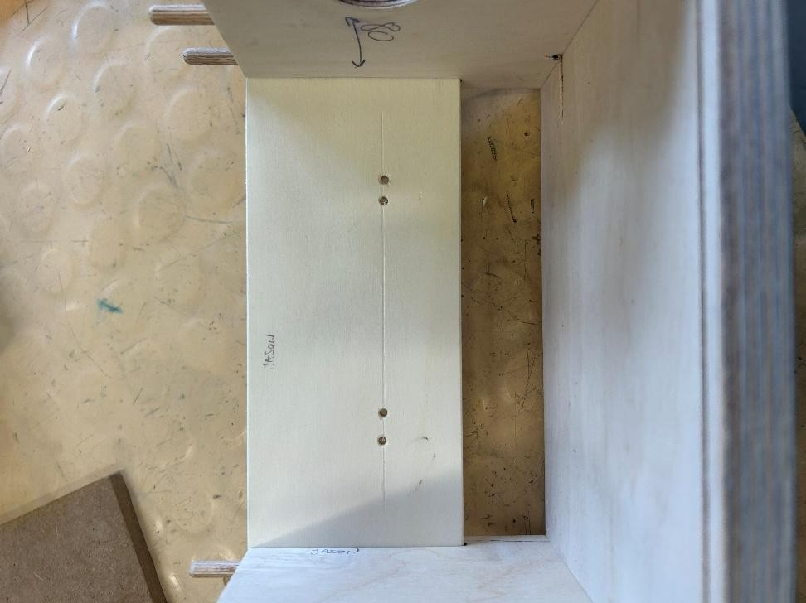

And carved out the space for the screen and the backplate and put it all together.
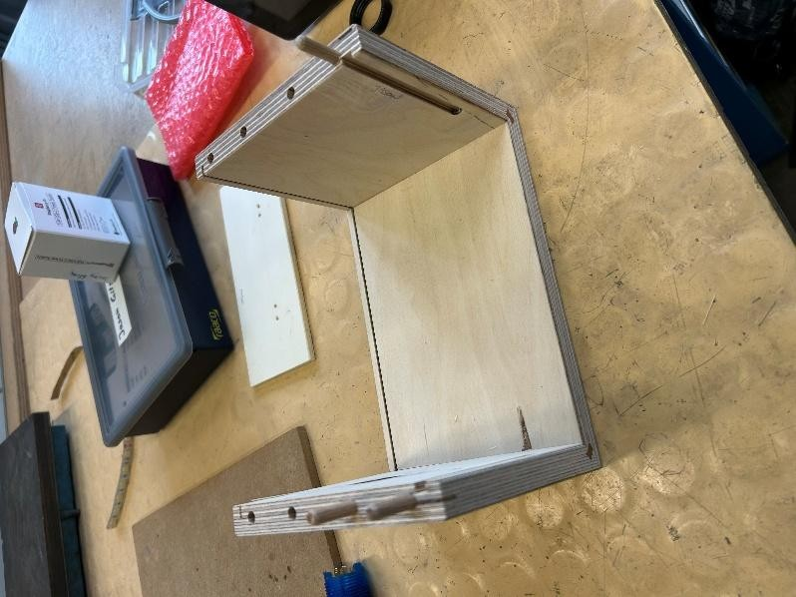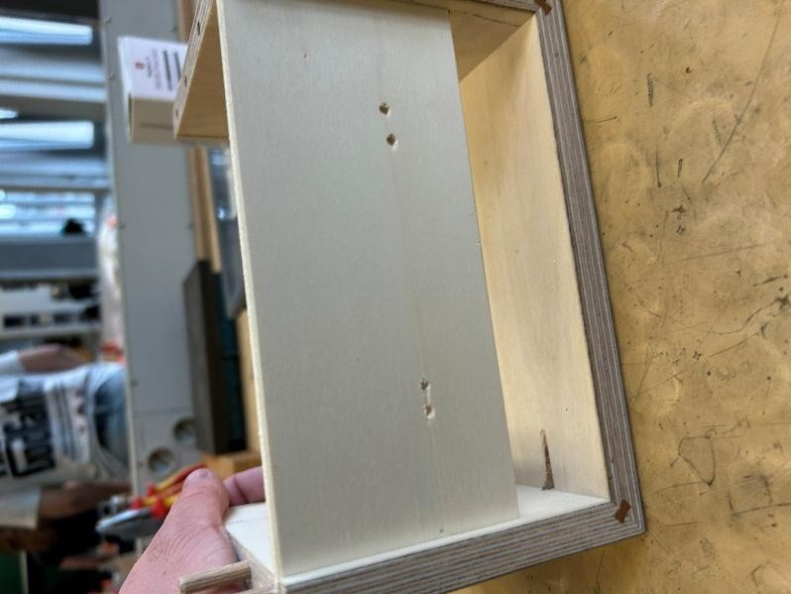

Finally, I put my raspberry pi in the box.

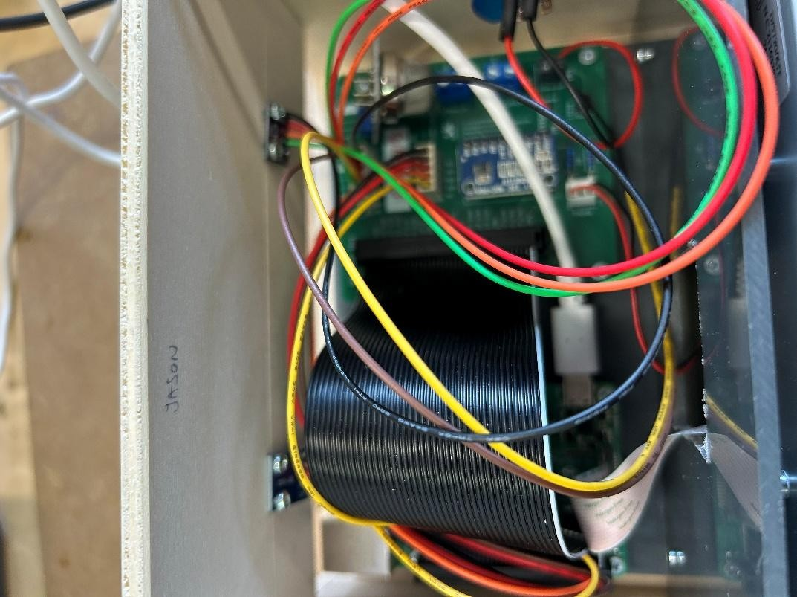

Button
First, I removed the shield cover from the cables and soldered them to the button.
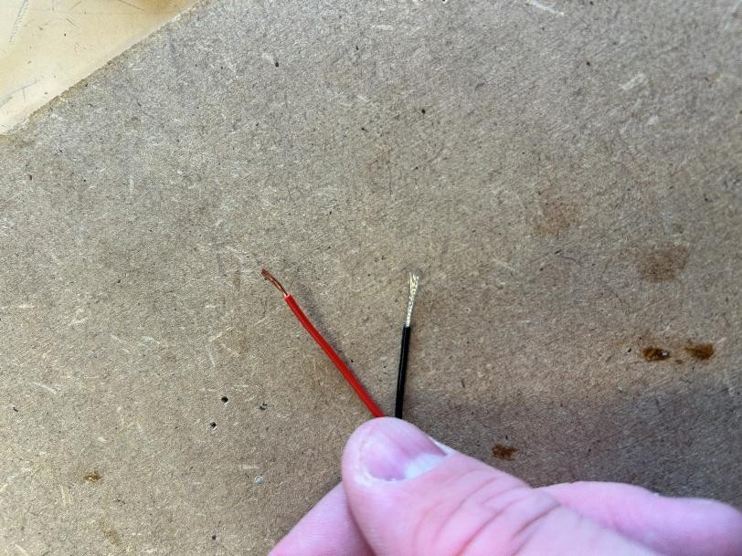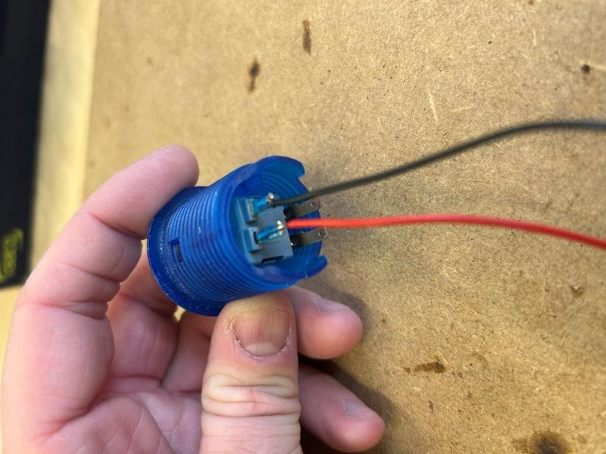

Then I added a heat shrink around the cables I just soldered to protect them.
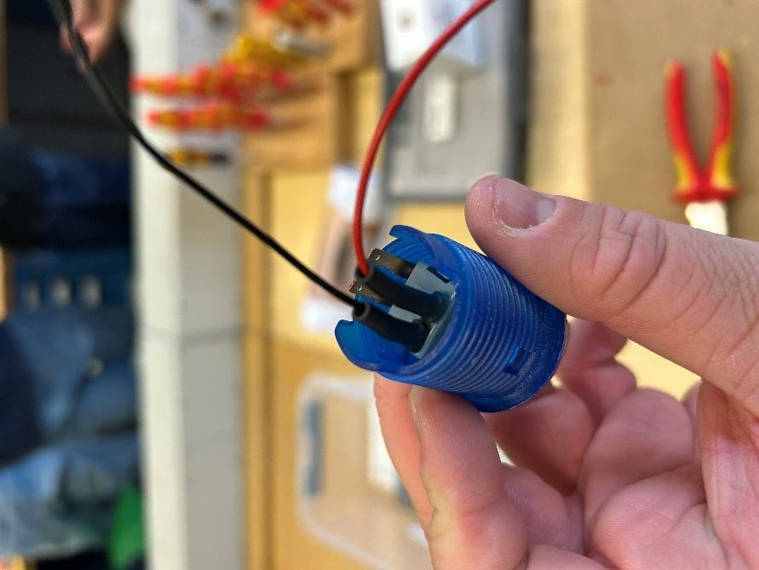

Finally, I put the button in the wooden case and connected it to the circuit board connector.

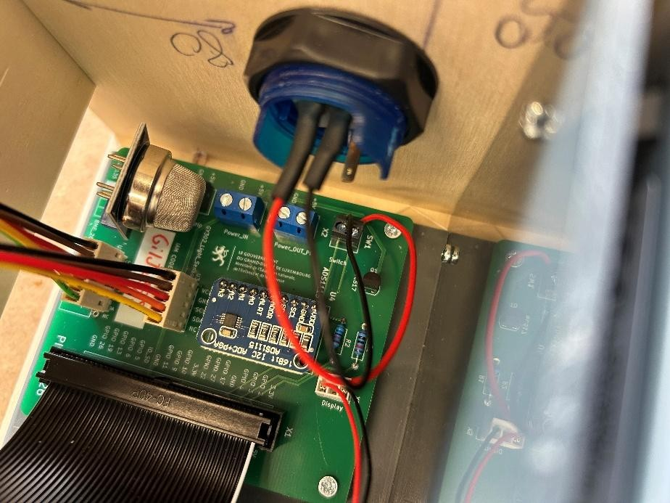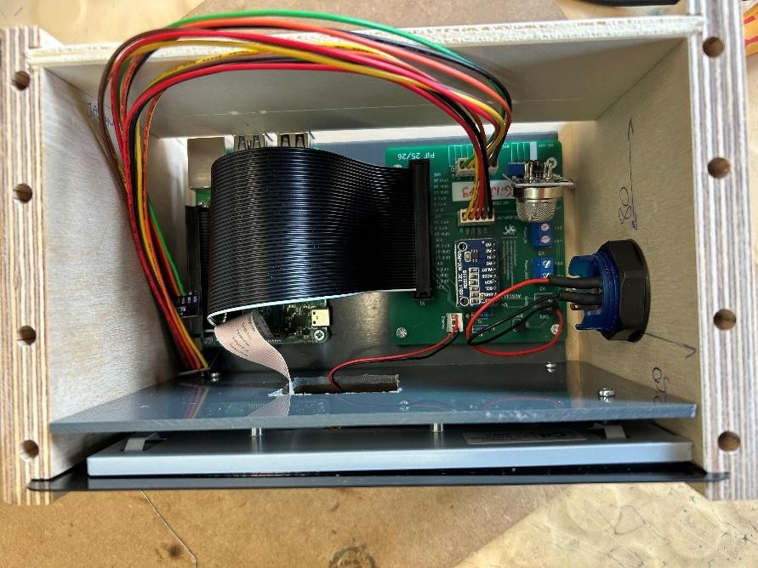

Video of proof of it working is attached as separate file.

Material List
- Lead
- Soldering station
- Drill
- Screws
- Button
- Cables
- Screwdriver

Userstory A7
- First, I prepared two cables, I removed the outer jacket on both sides so that I can solder it onto the LED strip and connect the other side to my circuit board.
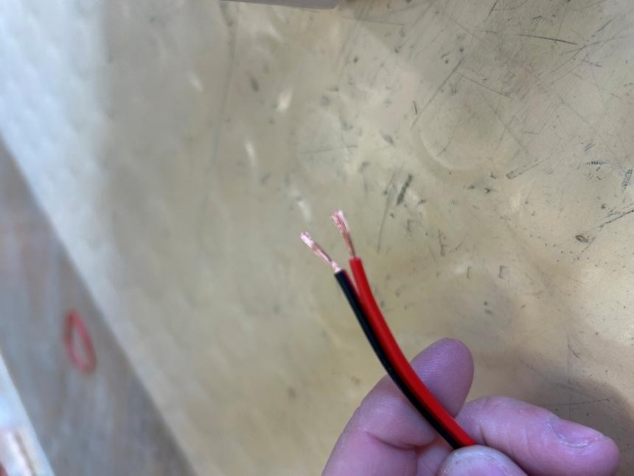

- The cable will go trough a hole on the side.

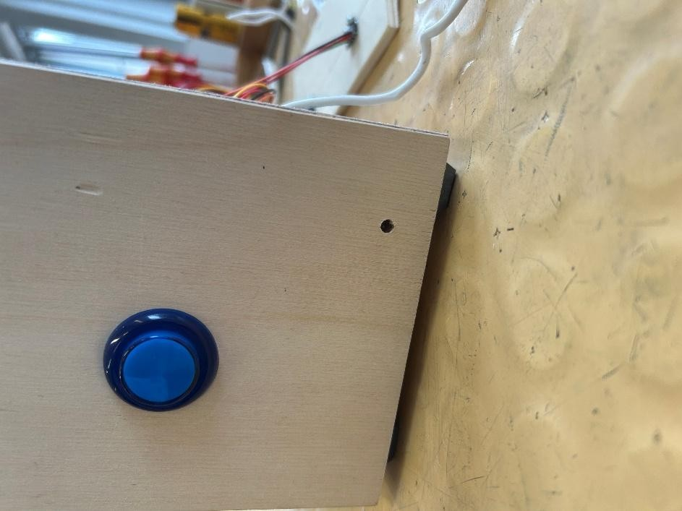

- I soldered the cables to the LED strip.

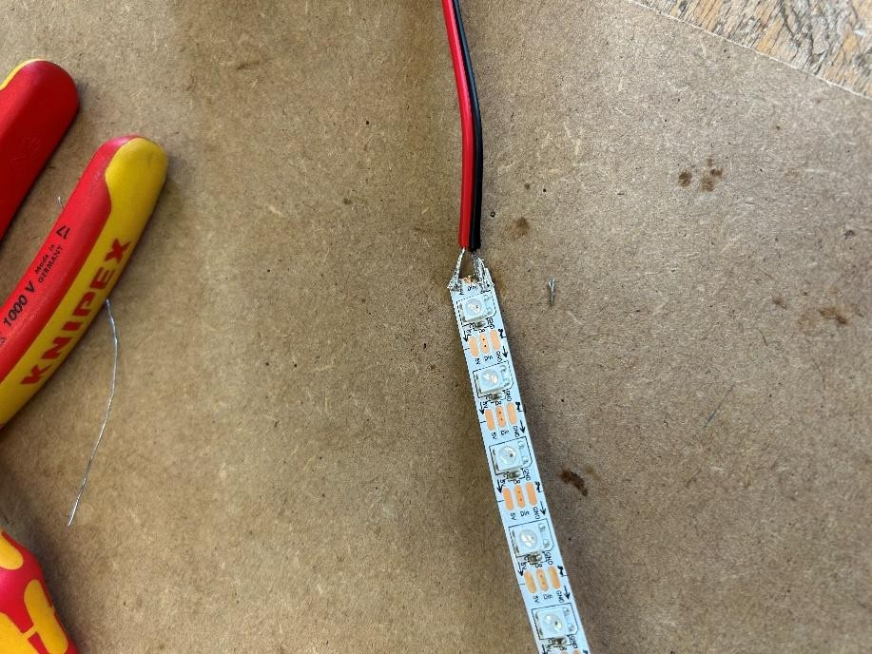

- Then I pushed the other side of the cable trough the hole.
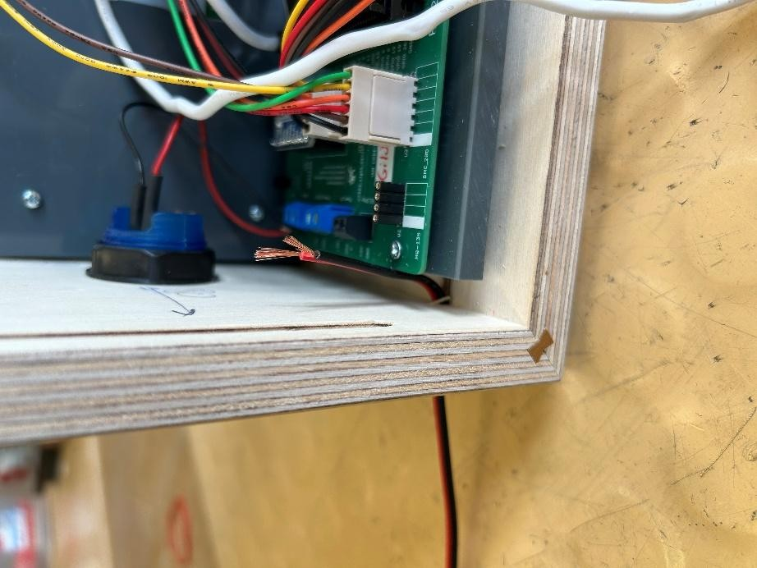
- And connected the cables to the circuit board.
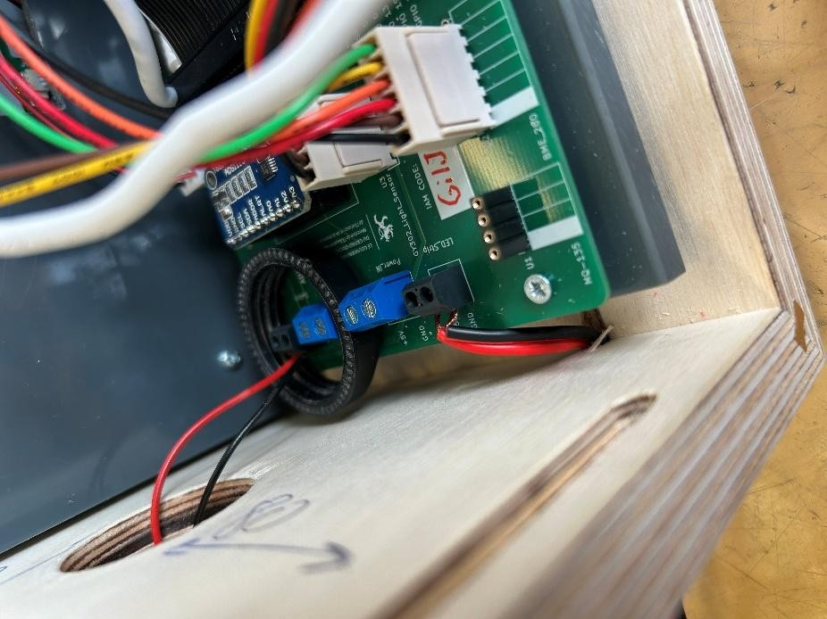

- I added a heat shrink where I connected the cables to the LED strip to keep the connection save.

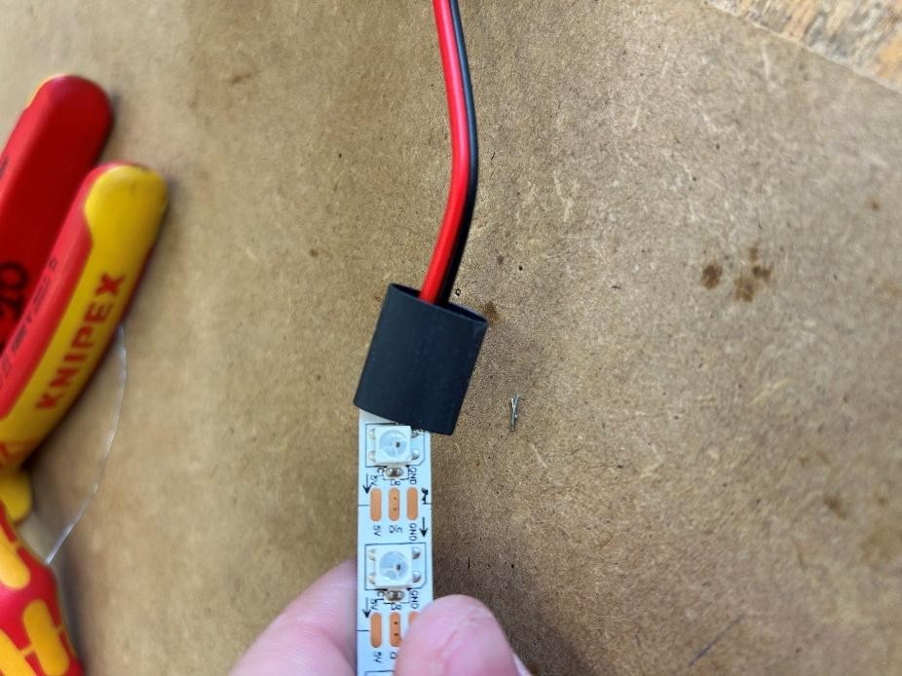

Experience
This task worked well and was easy to understand, however I made a small mistake by removing the jacket too short which made it harder to remove the shield from the conductors and soldering them together.

Equipment
- Shielded cable
- Diagonal cutter
- Soldering station
- Solder
- Heat shrink tube
- Wire stripper

